**APIGATEWAY POST**

Accept:application/json

Content-Type: application/json

{

"email": "card@gmail.com",

"name": "sant",

"lastName": "card",

"age": "29",

"city": "Envigado",

"country": "Colombia",

"EPS": "Sura",

"weight": "75",

"height": "185",

"profession": "engineer"

}

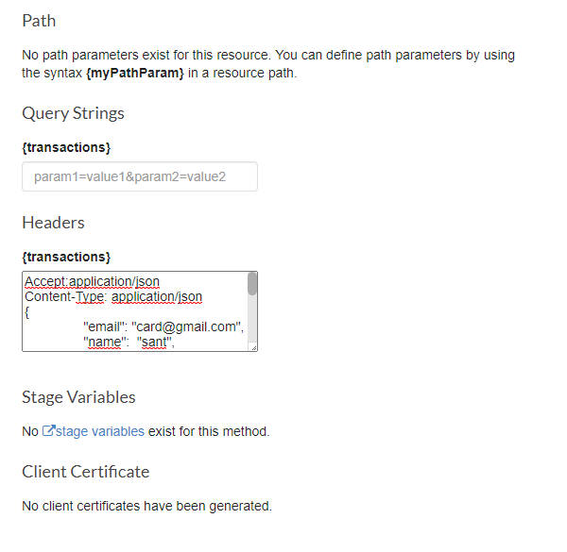

**LAMBDA POST**

var aws = require('aws-sdk');

var ddb = new aws.DynamoDB.DocumentClient();

exports.handler = (event, context, callback)=> {

// If the required parameters are present, proceed

// if (event.request.userAttributes.sub) {

var params = JSON.parse(event.body)

// -- Write data to DDB

let ddbParams = {

TableName: 'User',

Item: {

//"id": {"S": event.request.userAttributes.sub},

"email":params.email,

"name": params.name,

"lastName":params.lastName,

"age":params.age,

"city":params.city,

"country":params.country,

"EPS": params.EPS,

"weight": params.weight,

"height":params.height,

"profession":params.profession

},

};

let response = {};

// Call DynamoDB

ddb.put(ddbParams, function(err, data){

if(err){

//callback(err, null)

callback(null, {

statusCode: 500,

body: 'Error! -->'+err,

});

}else{

// callback(null,data)

callback(null, {

statusCode: 200,

body: 'Ok!',

});

}

});

};

**APIGATEWAY GET**

Se debe habilitar use lambda proxy integration en Integration Request

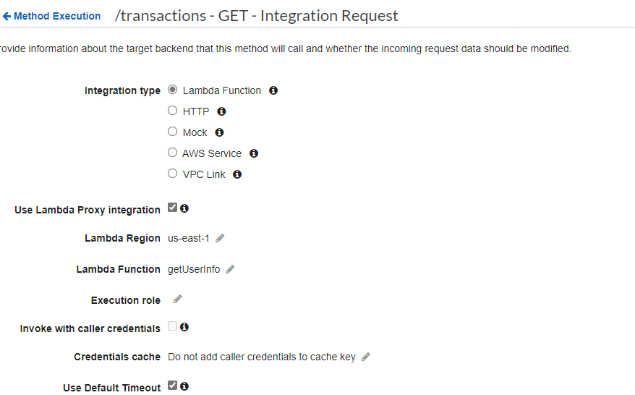

para probar

QUERY STRINGS

email=card

HEADERS

Accept:application/json

Content-Type: application/json

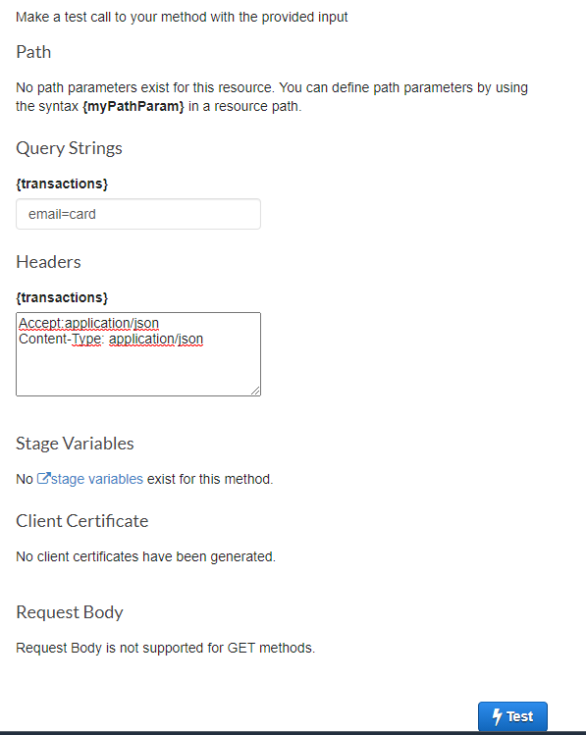

Para poder recibir los parámetros que envía la aplicación o postman se deben espicificar en URL Query String Parameters

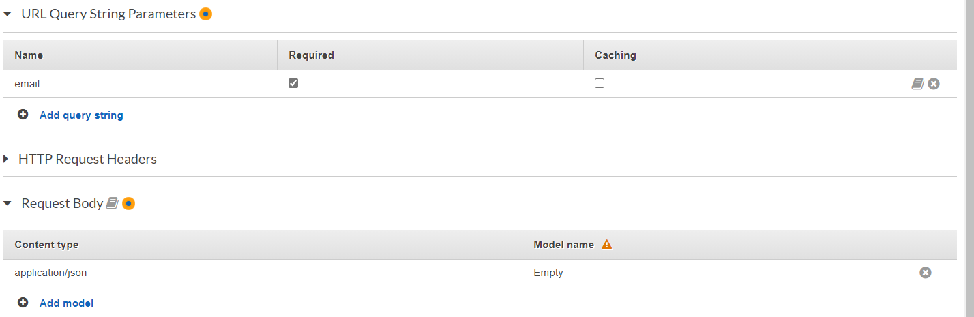

Además en el Integration Request se debe agregar un Mapping Templates. Se puede agregar el que trae por defecto (Method Request passthrough)

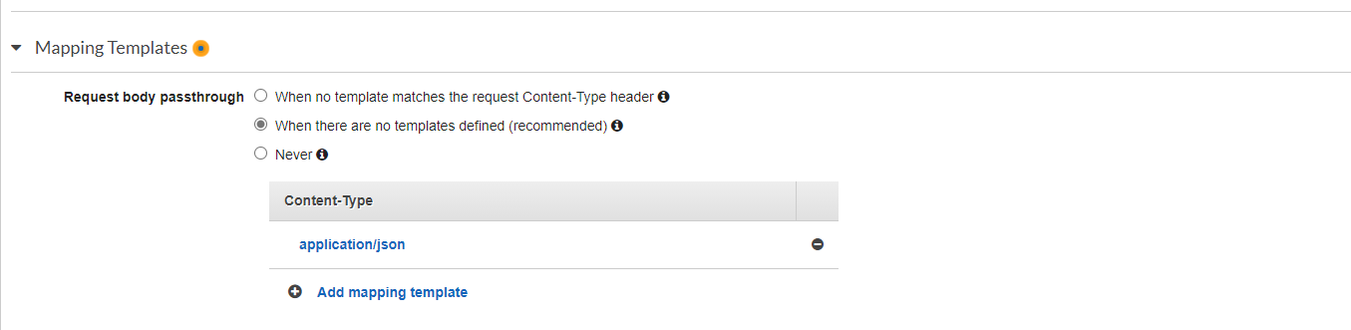

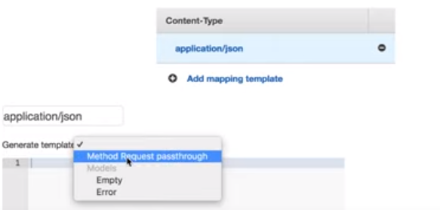

**Lambda GET**

// This is just a sample script. Paste your real code (javascript or HTML) here.

var aws = require('aws-sdk');

var ddb = new aws.DynamoDB.DocumentClient();

exports.handler = (event, context, callback) => {

// TODO implement

// if(event.httpMethod == 'GET'){

var email = event.params.querystring.email

var params = {

TableName: 'User',

Key: {

"email": email

}

};

ddb.get(params, function(err, data) {

if (err) {

//callback(err, null)

callback(null, {

statusCode: 500,

body: 'Error! -->' + err,

});

} else {

// callback(null,data)

callback(null, {

statusCode: 200,

body:JSON.stringify(data["Item"])

});

}

});

};

[Paso 3: Crear, leer, actualizar y eliminar elementos - Amazon DynamoDB](https://docs.aws.amazon.com/es_es/amazondynamodb/latest/developerguide/GettingStarted.NodeJs.03.html)